12:00 – 12:45 PM
Setting up GitHub, VSCode and Raylib Library. (Not much else)

12:45 – 1:10 PM
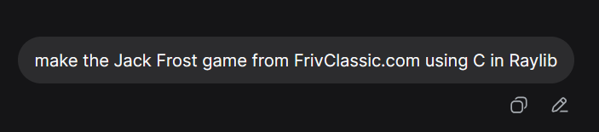
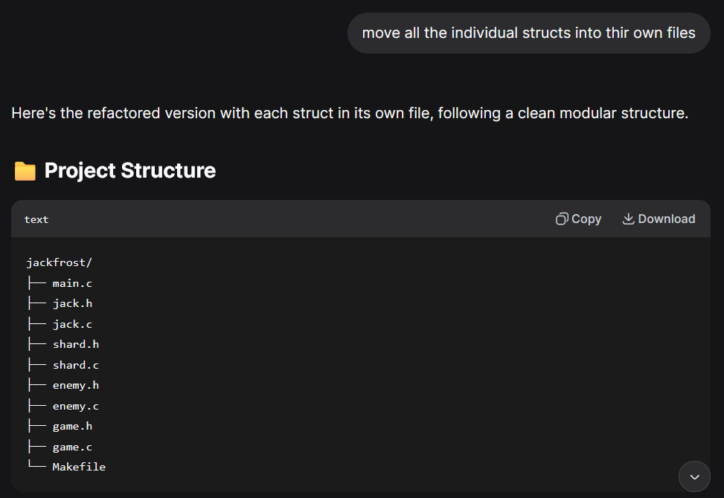
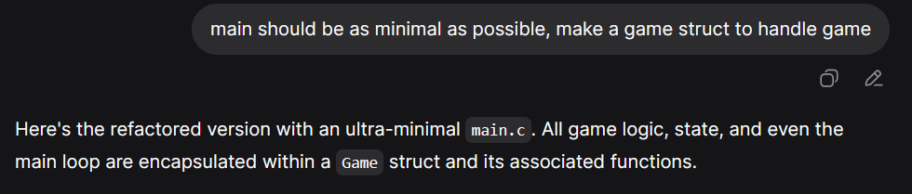
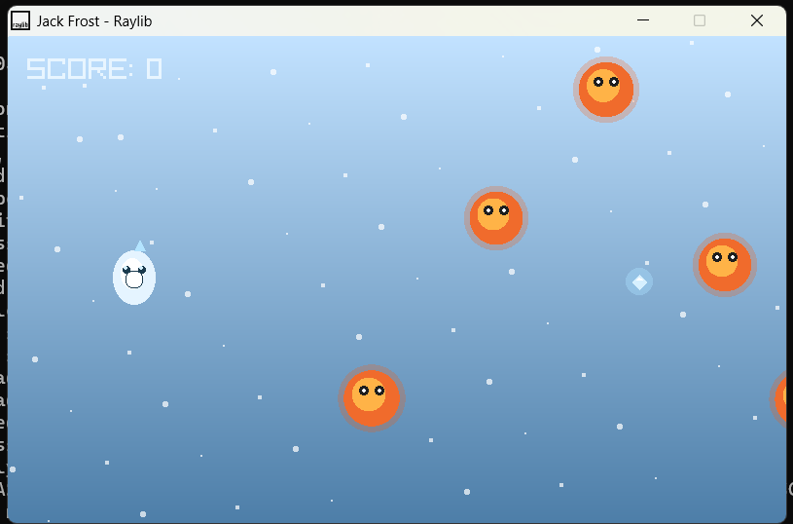
PS – NOT AT ALL WHAT I WANT THE GAME TO LOOK LIKE BUT the Project Structure is good.

1:10 – 1:30
